CCNA1 Lesson Plan – Chapter 2

Details

Course: CCNA1 – Introduction to Networks

Chapter: 2 Basic Switch and End Device Configuration

Objectives
Module Objective: Implement initial settings including passwords, IP addressing, and default gateway parameters on a network switch and end devices.

The students will:
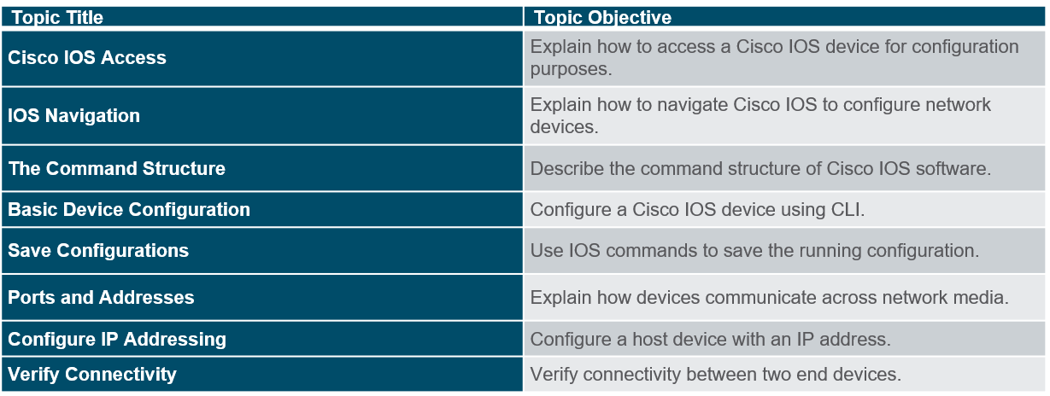

Resources
In addition to the normal resources found in this room we will need:
- Lecture Presentation
- Packet Tracer

Weekly – LABS
Note these are the minimum labs you should complete for the week.
Class 1
Review lab preparation file
2.3.7 (Navigate IOS) PT
2.5.5 (Initial Switch Settings) PT

Class 2
2.3.3.3 (Build Simple NW)
2.3.3.4 (SVI)
2.4.1.2 (Integrated Challenge) PT

Additional

- Chapter 2 Quiz

